Trustee

Application Pack

“Intellectual growth should commence
at birth and cease
only in death.”

Albert Einstein

Contents

About Falcon Support Services Page 3

Our Business Strategy Page 4

Our Strategy Impact Map Page 5

Job Description Page 6/7

Essential Roles of Trustees Page 8/9

Candidate Profile Page 10

How to apply: Page 11

About Falcon Support Services

Falcon Support Services provide supported accommodation and community projects to those that are homeless, at risk of homelessness or vulnerable in the community.

Our service helps vulnerable people by providing safe, secure accommodation in a positive learning environment. Our staff work alongside clients to help them develop their skills, so they can move away from homelessness to live independently and positively contribute to their community.

We believe that “where you are today does not define your tomorrow” and this is true in relation to our service users that use our service, our staff and our charity as a whole which has increased its bed spaces by 1200% in just 17 years, and now provides a whole spectrum of services for our service users journey; from rough sleeping to supported housing, move on accommodation and independence. Our approach is to never give up on inspiring change in vulnerable people.

The Charities Objectives are:

(a) The relief of need, hardship and distress experienced by homeless people and disadvantaged groups, regardless of age by the provision of emergency and other temporary accommodation and by the provision of support and advice services calculated to relieve their conditions of need.
(b) The relief of need, hardship and distress experienced by homeless people and disadvantaged groups, regardless of age by the provision of support and advice services calculated to relieve their conditions of need while accommodated within temporary accommodations and new tenancies when referred for such internally or by a Local Authority, Children and Family Service (CFS), Criminal Justice Services and other agencies with whom Falcon Support Service have Service Level Agreements.
c) To relief of need, hardship and distress experienced by vulnerable people regardless of age by the provision of support, advice, educational and community involvement services calculated to relieve their conditions of need when referred to such internally by Falcon Support Services e.m Ltd and its partner agencies or by any other support provider where a support agreement is in place.

Our values and operating principles which guide how we fulfil our mission are:

Dignity
We recognise that everyone is worthy of honour and respect as fellow humans. We develop and build trusting, accountable, non-judgemental relationships aspiring to release the potential for successful independent living in all our clients.
- Persistence
We believe that everyone deserves a second chance and we will not give up on an individual, subsequently we do not believe in lifelong bans. All willing clients are eligible to receive our help and support to the best of our ability.
- Collaboration
We believe that working in collaboration provides the best outcomes for our stakeholders. The success of our team relies on accountable, supportive and empathetic attitudes, working together to achieve the charities objectives. This teamwork ethic enables us to successfully collaborative and engage with services external to our own.
- Excellence
We feel fortunate to attract staff that go above and beyond, who are willing to engage with stakeholders with a high level of professionalism and understanding. Falcon Support Services strives to be a charity that continues to learn from good practice and develop through innovation.
More information about Falcon Support Services and what we do can be found on our website at www.falconsupportservices.org.uk

Business Strategy

- Prevent the cycle of homelessness by supporting communities

- Develop community hubs across Leicestershire that meet the needs in the community

- Provide specialist support for service users inhouse or through collaboration with partner agencies

- Supporting people back into work, education, training and volunteering

- Learn, influence, develop and co-produce services with those who have had real lived experience

- Offer a high standard of diverse and accessible accommodation

- Remove the barriers that those that are homeless face

- Further improve the quality of accommodation

- Providing increased housing options

- End Furniture poverty

- Organisational growth and sustainability

- Further improve our offer to employees and volunteers

- Increase income generation

- Improve our systems and processes to better operate, monitor and impact report

- Minimise our Environmental impact

Our Strategic Impact Map

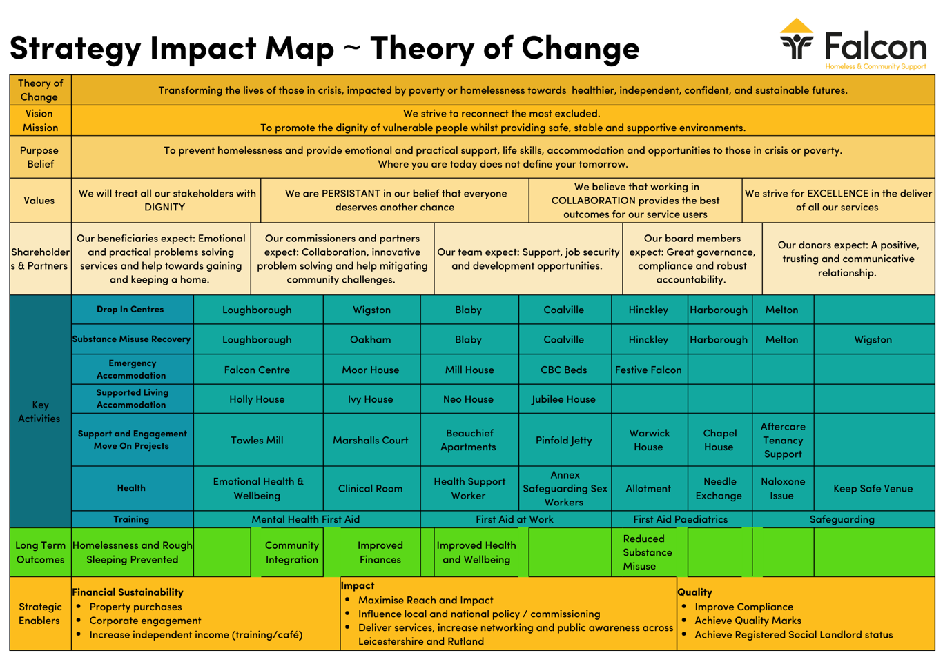
Job Description

Post title: Trustee

Location: Loughborough

Hours of duty: Approx. 18 hours per year

Responsible for: CEO, Staff, Volunteers, Trainees, and Student Placements

Purpose:
As an essential member of the charity the trustees will work with the board to provide feedback and support to help with growth, management and development of strategy and in line with the overall strategy.

Trustees will contribute to the charity by bringing independence, impartiality and a wider experience from relevant sectors, therefore recruiting those with an operational/strategic management, youth and community, sales, marketing, housing, mental health, substance misuse, professional and financial backgrounds.

Tasks and Responsibilities:
Trustees have overall legal responsibility for the charity. They must ensure that:

The charity pursues its objects or purposes and complies with the law, as set out in its governing document.

The assets (including funds, investments and property) of the charity are protected and used exclusively to pursue its purposes.

The charity remains solvent and is not exposed to undue risk.

Trustees must act at all times in the best interests of the charity and its beneficiaries. They must avoid situations where their personal or other interests conflict with the interests of the charity and must not profit from their role unless it has been allowed.

Work collaboratively on a strategy with the board, including seeking investors and developing networks

In carrying out their duties, trustees have a duty of care to act reasonably and prudently and a higher duty in areas of their own expertise.

The trustees’ board takes decisions collectively and they must meet as they need to in order to carry out their responsibilities.

Trustees can only take decisions independently in their role as trustee if the governing document or statutory provisions, and a decision of the trustee board, gives them the authority to do so. An individual trustee cannot bind the other trustees to a course of action unless it has been authorised by the trustees as a whole.

Trustees are not expected to be experts in every field, but they have a duty to take advice when they are not confident about taking a decision.

Trustees need to remember that duties such as that to avoid conflicts of interest, act with integrity and not obtain personal benefit are triggered not only by their own interests but also those of individuals or organisations connected to them by

personal financial linking or duties. For example, family, business partners or other trusteeships. Such people are referred to as “connected persons” or persons “sharing a common purse”.

Trustee Person Specification Essentials
- Committed to the charities aims, values and mission statement

- Experience of networking at a senior level within organisational management, sales, marketing, housing or finance

- Able to represent Falcon Support Services whenever reasonably required at a strategic level

- Understanding of the legal duties, responsibilities and liabilities of the Trustee role

Personal Qualities
- Ability to see bigger picture

- Non-judgemental, impartial and fair

- Willingness to contribute

- Tactful and diplomatic

- Respectful

- Willingness to be involved and learn from others

- Specific skills and abilities relevant to the strategic development of the charity

Vision
- Strategic vision

- Excellent communication, persuasive and interpersonal skills

- Ability to work as part of and to contribute to the team

Experience
- Experience of developing and implementing strategy

- Senior organisational management

- Implementing change and organisational growth

- Strategic networking, building and maintaining relationships to contribute organisational growth

Trustee Meetings
Meetings are usually held every 4 to 6 weeks with scheme reports sent out prior, meetings normally last approx. 1.5-2 hours and can be attended by conference call with prior arrangement. In line with the volunteer policy any expenses will be reimbursed.

As well as the quarterly trustee meetings there will be an AGM to attend. Trustees will also where possible provide support to the CEO or board by email or phone.

Term of Office
One year, where the board can stand down and/or be re-elected.
Essential Roles of a Trustee

1. Set and maintain vision, mission and values

2. Develop strategy

The trustee board is responsible for establishing the essential purpose or mission of the organisation. They are also responsible for guarding its vision and values. Together, the charity board and chief executive officer develop long-term strategy. Meeting agendas reflect the key points of the strategy to keep the organisation on track.

3. Establish and monitor policies

The trustee board creates policies to govern organisational activity. These cover:

Guidance for staff
Systems for reporting and monitoring
An ethical framework for everyone connected with the organisation
Conduct of trustees and board business

4. Set up employment procedures

The charity trustee board creates comprehensive, fair and legal personnel policies. These protect the organisation and those who work for it. They cover:

Recruitment
Support
Appraisal
Remuneration
Discipline

5. Ensure compliance with governing document

The governing document is the rulebook for the organisation. The board makes sure it is followed. In particular, the organisation's activities must comply with its charitable objectives.

6. Ensure accountability

The board should ensure that the organisation is accountable as required by law to:

The Charity Commission
The Inland Revenue
Customs and Excise
The Registrar of Companies (if it is a company limited by guarantee).
The board also needs to make certain that the organisation is accountable to donors, beneficiaries, staff, volunteers, and the general public. This means publishing annual reports and accounts and communicating effectively.

7. Ensure compliance with the law

The board is responsible for making sure that all the organisation's activities are legal.

8. Maintain proper fiscal oversight

The board is responsible for effectively managing the organisation's resources so it can meet its charitable objects. It:

Secures sufficient resources to fulfil the mission
Monitors spending
Approves the annual financial statement and budget
Provides insurance to protect the organisation from liability
Seeks to minimise risk
Participates in fundraising (in some organisations)
Ensures legal compliance

9. Select, manage and support the chief executive

The board creates policy covering the employment of the chief executive. It selects and supports the chief executive and reviews his or her performance.

10. Respect the role of staff

The board recognises and respects the domain of staff responsibility. At the same time, it creates policy to guide staff activities and safeguard the interests of the organisation.

11. Maintain effective board performance

The board keeps its own house in order. It takes steps to establish:

Productive meetings
High standards of trustee conduct
Effective committees with adequate resources
Development activities
Recruitment and induction processes
Regular performance reviews
Partnership with consultants where necessary

12. Promote the organisation

Through its own behaviour, governance oversight and activities on behalf of the organisation the governing board enhances and protects the reputation of its organisation. Board members are good ambassadors for the organisation.

Candidate Profile

We are seeking enthusiastic individuals that are extremely self-motivated and possess a “can do” attitude.

As a trustee:

- Your skills will align with our strategic direction

- You will have sector knowledge/experience or technical skills in one of the specified areas:

  - Accounting/Finance
  - Legal/Housing Law
  - Marketing/PR/Communications
  - Fundraising/Bid Writing
  - Human resource management
  - Health
  - Strategic development/implementation/business

- You will be motivated, pro-active and attentive with a passion for the cause, wanting the charity to succeed

- You will actively participate in discussions, bringing different points of view

- You will seek clarification when needed

- You will absorb and analyse information

- Willingness to critically question and challenge advisers, being assertive without being aggressive

What you can expect to get out of the role

- A sense of achievement, satisfaction and purpose

- An opportunity to learn about a new sector

- Put your skills and experience to use and make a lasting difference to a cause you care about

- Learn about the management and strategy side of charities by taking on a leadership role

- Work with new and interesting people from diverse background

- The experience will enhance your CV and may open doors to new career paths

How to apply

TRUSTEE APPLICATION FORM

Please complete the application form and send to Jane.Fele@falconsupportservices.org.uk

Name
Home Address | Post Code
Telephone | Mobile |  | Work |  | Email
Date of Birth
(Requested by Companies House)
Please indicate if you have experience/skill in any of these areas or any other skills/experience you think would be useful
 | Human Resources |  |  | Management
 | Financial / Accounting |  |  | Housing/homelessness/welfare
 | Fundraising/Marketing |  |  | Other
 | Legal
Please give a brief statement of why you are interested in becoming a trustee and what you hope to gain from the experience.
The Trustees generally meet every six weeks on a Monday evening. Occasionally there will be a requirement for additional meetings, work and training. Are you able to give this commitment? YES/NO

Trustee applicant’s declaration of eligibility:
I declare that:
- I am over age 18.
- I am not an undischarged bankrupt.
- I have not previously been removed from trusteeship of a charity by a Court or the Charity Commission.
- I am not under a disqualification order under the Company Directors' Disqualification Act 1986.
- I have not been convicted of an offence involving deception or dishonesty (unless the conviction is spent).

___________________________ _____________________
Signature Date

